**Administrative Access**

[www.dialndoc.com](http://www.dialndoc.com)

Select Customer Login

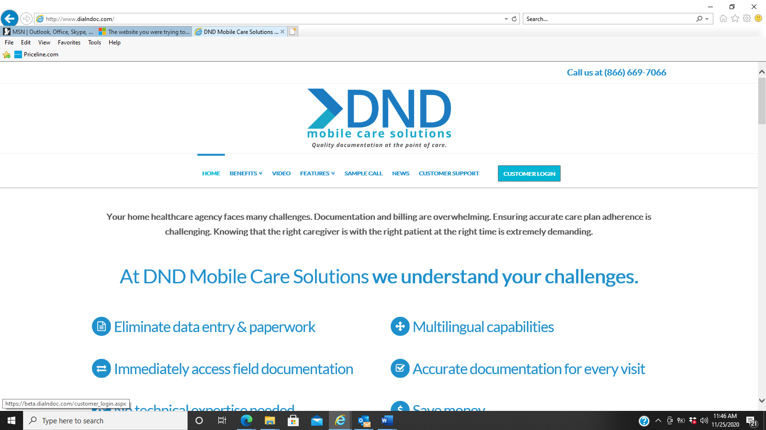

Enter the Customer Code (Agency ID), Access Code, and Password

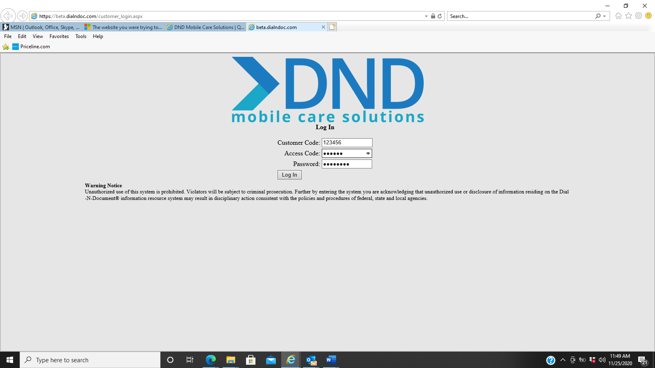

Once logged in, select the Admin. tab and then the Employee Groups Tab.

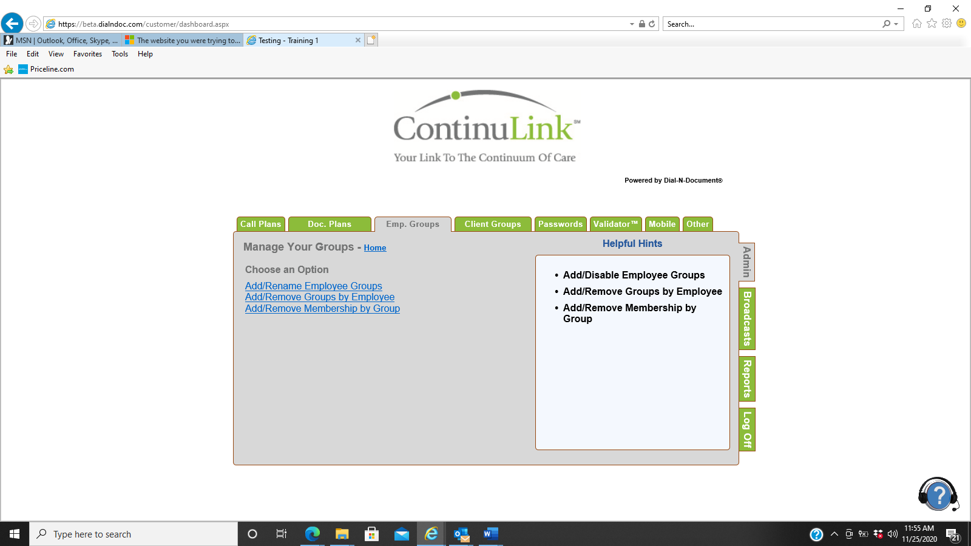

You will need to add the Administrative member into two groups. They should be added into the ADM group and the Password Reset group. The ADM group will give them Administrative access to DND. The employee must be entered into Continulink as a caregiver in order to transfer to DND.

Add Remove Groups by Employee will allow you to add multiple people into one group. Add Remove Employee by Groups will allow you to add one person to multiple groups at a time.

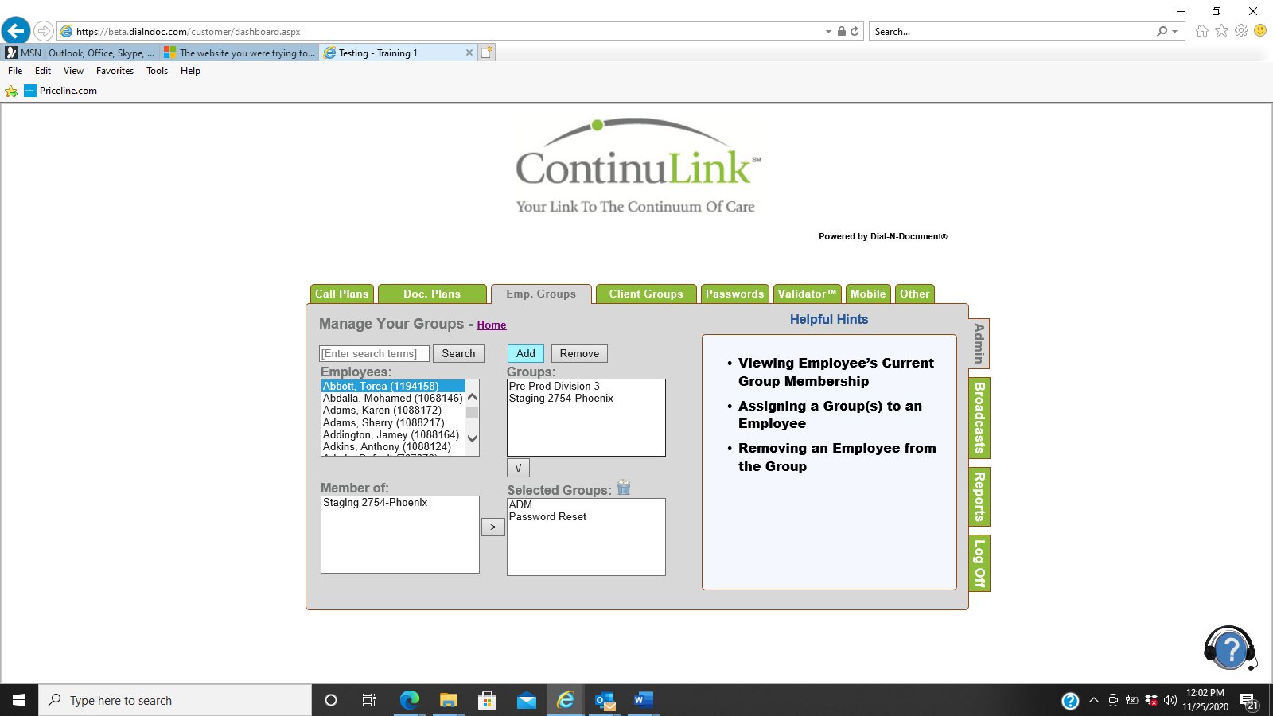

In Add Remove Employee by Groups, search for your employee then select the employee by clicking on their name. Move the ADM and Password Reset Groups down to the Selected Groups box. Click Add. When you reselect and refresh the employee chosen, the groups will now appear in the Member of box. They now can call the Password Creation line and create their password.

**Creating Your Password**

1. Call: 1-877-814-3820
2. Once prompted, enter your employee access code followed by the # key.
3. Once prompted, enter your agency ID, followed by the # key.
4. Once prompted, enter a password 4-8 digits in length, followed by the # key.
5. The system will tell you that your password has been created and will disconnect.

**Note: Make sure that you use a password code that you can remember. If for some reason you forget your password, you will need to contact your supervisor so that you can be reset in the system, and then must call into the Password Creation line again to create another password.**