What is Broadcast Announcement Messaging?

Broadcast Announcement Messaging is a dynamic tool that can be used to communicate with your field staff regarding patient instructions or information, schedule changes, cancellation notices, notification for licensing renewals, staff meetings, motivational messages, or whatever else you would like to communicate with your staff. Broadcast Announcement enables an agency to send either audio messages to your staff that they will receive whenever they call in to the system, or text messages that they can receive anytime. You may choose to send a message to one individual, several people, an entire group of employees, such as all of your HHA’s or everyone working the overnight shift, or even every member of you field staff at once.

There are three types of Broadcast Announcement. Employee Broadcast Announcements are assigned to employees or groups of employees and are general messages or pertaining to something specific for one or multiple employees. Patient Centric Broadcast Announcements are messages primarily about the client or patient, for field staff that have been assigned the message and will be heard upon calling in from a specific patient location. Text Broadcast Messaging enables you to send text messages directly from Dial-N-Document to individual employees or groups of employees.

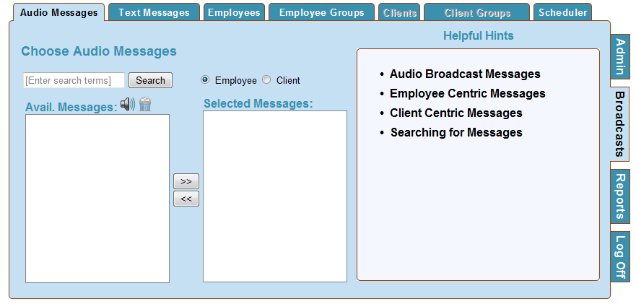

Recording a Broadcast Announcement…
The process of recording and creating a Broadcast Announcement that can be sent out to your field staff is as easy as recording a voice mail message. The process for recording the message is the same no matter if it is an employee message or patient centric message.

To Record a Broadcast Message…
- Dial the toll free number your agency uses for documentation.
- “Welcome to Dial-N-Document. Please enter you access code followed by the # key.” Enter your Administrative level access code. Depending upon the partner program you are using you may be required to have one code as an administrative level code and another code if you ever do visits in the field and must document visit information as well. Please check your training materials or ask your customer service representative if you are unsure of what code to use.
- “Please enter your agency ID followed by the # key.” Enter your agency ID number. Please contact your customer service representative if you are unsure of your agency ID.
- Are you here as an administrator? Press 1 for yes, 2 for no. Press 1 to indicate you are an administrator and want to record a broadcast announcement.
- “Would you like to record an announcement for a patient? Press 1 for yes, 2 for no.” Select your desired response. If you select no, the system will automatically assume you want to record an employee centric announcement.
- “At the sound of the tone, please begin speaking. When you are finished press the pound key.”
- “Enter 1 to review your recording, enter 2 redo your recording, enter 3 to save your recording.”
- “Would you like to record another Broadcast Announcement? Press 1 for yes, 2 for no.”
- “Thank you for using Dial-N-Document.” Call will disconnect.

The message(s) that you have just recorded will be available for you to send out to your employees in the field. You are now ready to assign the message via the Dial-N-Document web site.

Scheduling an Employee Audio Broadcast Message

Once you have accessed the Broadcast Messaging section successfully you must choose whether you are assigning a message to an employee or if you are assigning a patient centric message. At the top of the screen you will see two radial buttons, one for Employee and one for Patient. Select the Employee radial button.
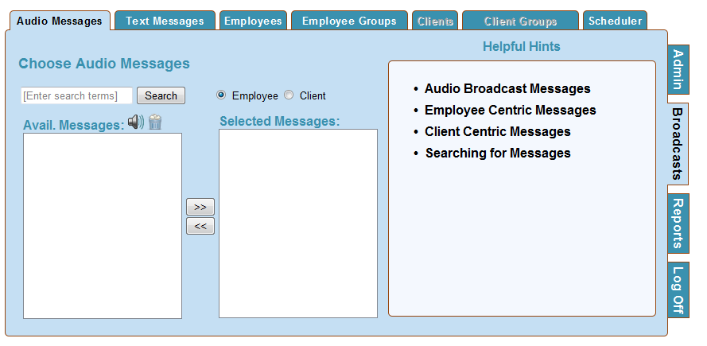
- Search for your desired message by leaving the search term box empty and clicking the Search button to view all messages or enter a search term to view specific matches.
- Click on a message in the Avail. Messages box and click the speaker icon to listen to it.
- Click the arrow button pointing to the right to select a message.

Once you have selected the message you wish to schedule move to the either the Employee or Employee Groups Tab depending upon which employees you wish to hear the message.
How to Disable a Broadcast Message
Select a message from the list of available messages by single clicking on it using your mouse. Then click on the trash can icon to disable the message.
Disabling a message DOES NOT disable any active schedules using this message. You must manually disable those schedules.

Employees
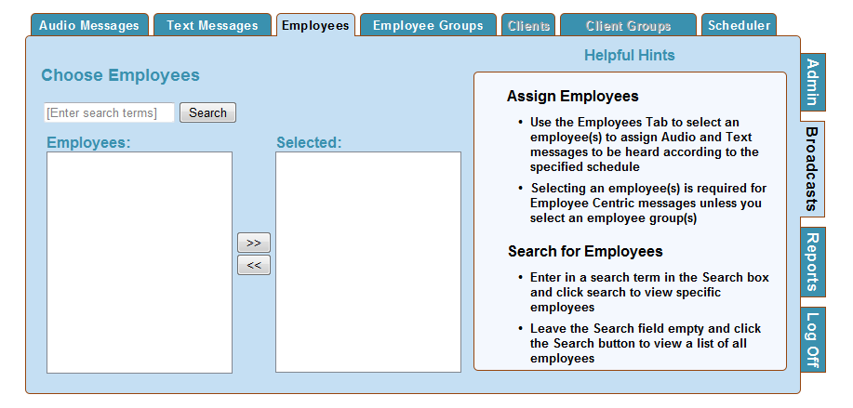
Search for Employees
- Enter in a search term in the Search box and click search to view specific employees
- Leave the Search field empty and click the Search button to view a list of all employees

Assign Employees
- Use the Employees Tab to select an employee(s) to assign Audio and Text messages to be heard according to the specified schedule
- Selecting an employee(s) is required for Employee Centric messages unless you select an employee group(s)
- Click on the name of the employee(s) that you would like to hear the message and then click the arrow button that points to the right. The employee will appear in the Selected box.
- To select multiple employees at the same time use the shift or control keys.

Employee Groups
Use the Employee Groups Tab to select an employee group(s) to assign Audio and Text messages to be heard according to the specified schedule.
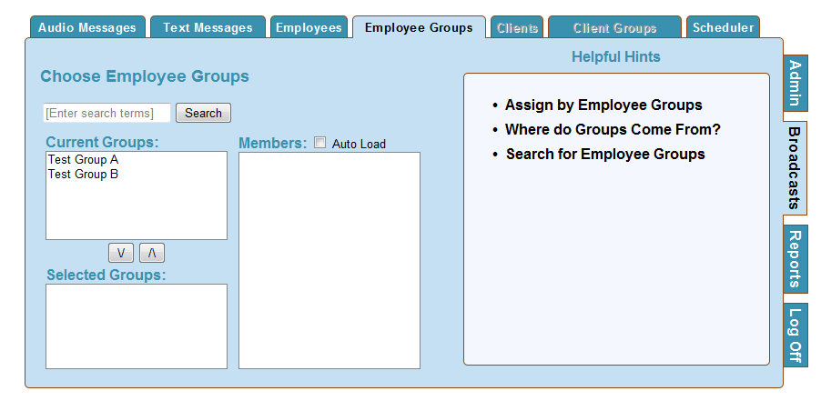
Selecting group(s) is an optional step in assigning a message to be heard or sent.

Where do Groups Come From?
Groups are created in your billing, payroll and scheduling software and are then transferred to Dial-N-Document. To learn more about creating and managing groups contact your billing/payroll company or look in the materials they have provided.
Search for Employee Groups
- Enter in a search term in the Search box and click search to view specific employee groups
- Leave the Search field empty and click the Search button to view a list of all employee groups
- Click the Auto Load Box and then the Group Name to view the Group members.
Selecting an Employee Group
- Click on the Group(s) in the Current Groups box
- Click the arrow pointing down to select the group(s)

Scheduling a Message
The Scheduler Tab is where you will decide how the message that you are assigning will be heard. The Scheduler Tab enables you to decide how often the message should be played, the message priority, what type of call the message will play on, duration or how long the scheduled message will be active.
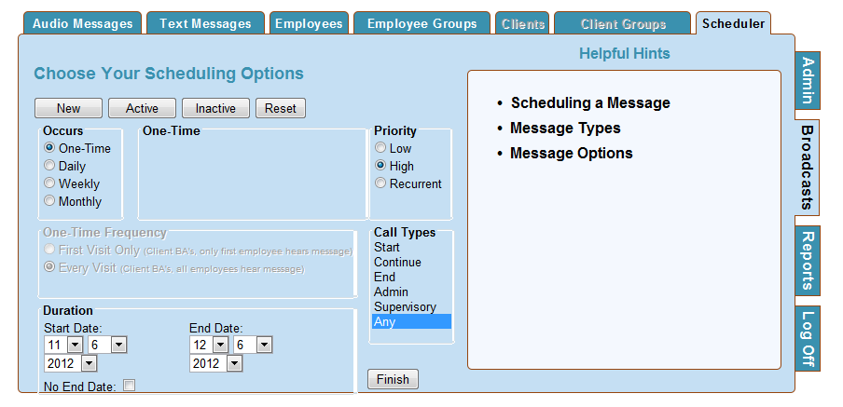
Message Types
- New - The New tab shows the scheduler itself for creating new schedules
- Active - The Active tab shows active message schedules.
- Inactive - The Inactive Tab shows message schedules that have either been inactivated or have expired.
- Reset - Reset will clear all selections.

Message Options
Occurs
One Time messages will play once for the intended recipients within the specified duration. Daily messages will play repeatedly based upon the pattern of every 1,2,3,4,5 or 6 days for the specified duration. Weekly messages play every 1-12 weeks for the specified duration. Weekly messages can also be scheduled to play on a specific day of the week.
Monthly messages can be scheduled to play on a specific date of the month and repeat every 1-12 months or can be scheduled to play on the 1st-5th Sunday - Saturday of every 1-12 months.

Priority
Low priority messages can be skipped by the employee who has been assigned to hear the message. High priority messages cannot be skipped and the employee must listen and decide if they want to delete it, save it or listen to it again before continuing on. Recurrent messages will play regardless of whether they have been heard previously.

Duration
Duration defines a span of time for the message schedule to remain active. If a date range is entered in Duration, then the message will be available to be heard for that span and will expire and no longer play after the end duration date. If the intended recipient(s) does not call in during that time span, then the message schedule will expire without the message being heard. If the No End Date box is checked, the message schedule will play as designed until manually ended by an Administrator from your agency.

Once you have selected how the message should be heard, click the Finish button to save the schedule. Once you have scheduled the message you will see a message that tells you that the message has been successfully scheduled.
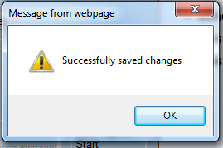

Scheduling a Client Centric Audio Broadcast Message

Once you have accessed the Broadcast Messaging section successfully you must choose whether you are assigning a message to an employee or if you are assigning a patient centric message. At the top of the screen you will see two radial buttons, one for Employee and one for Patient. Select the Client radial button.
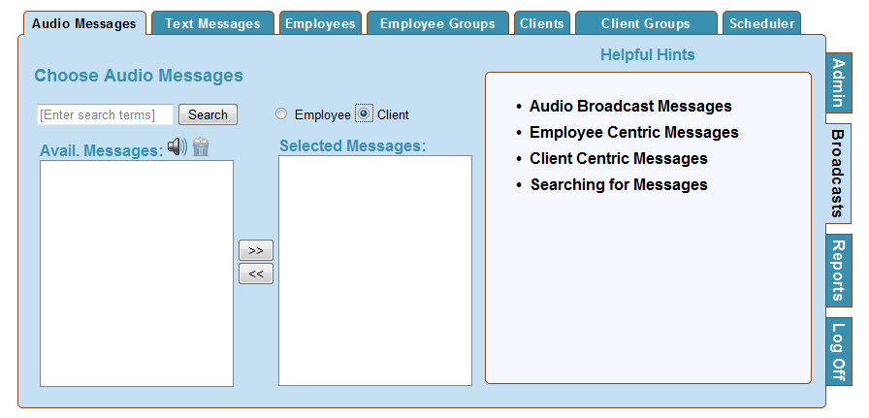
- Search for your desired message by leaving the search term box empty and clicking the Search button to view all messages or enter a search term to view specific matches.
- Click on a message in the Avail. Messages box and click the speaker icon to listen to it.
- Click the arrow button pointing to the right to select a message.

Once you have selected the message you wish to schedule move to either the Employee or Employee Groups Tab if you wish to schedule the message to only be heard by a specific employee(s) caring for the client, or to the Client or Client Groups Tab to decide what client(s) phone you would like the message to play from.
How to Disable a Broadcast Message
Select a message from the list of available messages by single clicking on it using your mouse. Then click on the trash can icon to disable the message.
Disabling a message DOES NOT disable any active schedules using this message. You must manually disable those schedules.

Employees
Assigning an employee or employee group to hear the message is an optional step for Client Centric Broadcast Messages. If you assign a specific employee(s) or employee group(s) to hear the message, then only those employees will hear the message regardless of any other employees that may care for the patient and call to document from the patient’s phone.
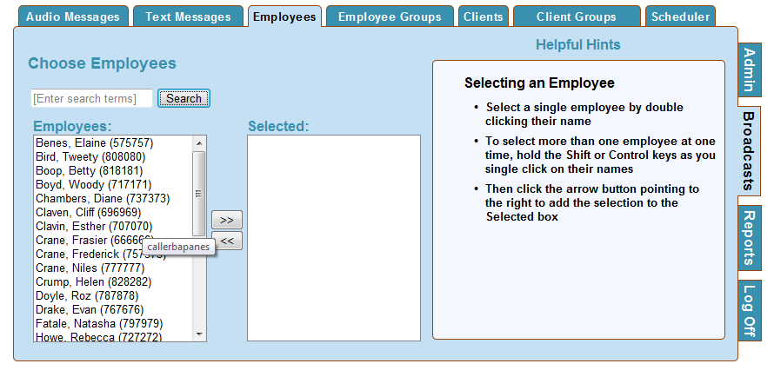
Search for Employees
- Enter in a search term in the Search box and click search to view specific employees
- Leave the Search field empty and click the Search button to view a list of all employees

Assign Employees
- Use the Employees Tab to select an employee(s) to assign Audio and Text messages to be heard according to the specified schedule
- Selecting an employee(s) is not required for Client Centric messages.
- Click on the name of the employee(s) that you would like to hear the message and then click the arrow button that points to the right, or double click on the name. The employee will appear in the Selected box.
- To select multiple employees at the same time use the shift or control keys.

Employee Groups
Assigning an employee group to hear the message is an optional step for Client Centric Broadcast Messages. If you assign a specific employee group(s) to hear the message, then only those employees in the group will hear the message regardless of any other employees or employee groups that may care for the patient and call to document from the patient’s phone.
Where do Groups Come From?
Groups are created in your billing, payroll and scheduling software and are then transferred to Dial-N-Document. To learn more about creating and managing groups contact your billing/payroll company or look in the materials they have provided.
Search for Employee Groups
- Enter in a search term in the Search box and click search to view specific employee groups
- Leave the Search field empty and click the Search button to view a list of all employee groups
- Click the Auto Load Box and then the Group Name to view the Group members.
Selecting an Employee Group
- Click on the Group(s) in the Current Groups box
- Click the arrow pointing down to select the group(s), or double click on the group name to automatically move it to the Selected Groups box.

Scheduling a Message
The Scheduler Tab is where you will decide how the message that you are assigning will be heard. The Scheduler Tab enables you to decide how often the message should be played, the message priority, what type of call the message will play on, duration, and how long the scheduled message will be active.
Message Types
- New - The New tab shows the scheduler itself for creating new schedules
- Active - The Active tab shows active message schedules.
- Inactive - The Inactive Tab shows message schedules that have either been inactivated or have expired.
- Reset - Reset will clear all selections.

Message Options
Occurs
One Time messages will play once for the intended recipients within the specified duration. Daily messages will play repeatedly based upon the pattern of every 1,2,3,4,5 or 6 days for the specified duration. Weekly messages play every 1-12 weeks for the specified duration. Weekly messages can also be scheduled to play on a specific day of the week.
Monthly messages can be scheduled to play on a specific date of the month and repeat every 1-12 months or can be scheduled to play on the 1st-5th Sunday - Saturday of every 1-12 months.

Priority
All Client Centric Messages are automatically designated as high priority. High priority messages cannot be skipped and the employee must listen and decide if they want to delete it, save it or listen to it again before continuing on. Recurrent messages will play regardless of whether they have been heard previously.

Duration
Duration defines a span of time for the message schedule to remain active. If a date range is entered in Duration, then the message will be available to be heard for that span and will expire and no longer play after the end duration date. If the intended recipient(s) does not call in during that time span, then the message schedule will expire without the message being heard. If the No End Date box is checked, the message schedule will play as designed until manually ended by an Administrator from your agency.

Once you have selected how the message should be heard, click the Finish button to save the schedule. Once you have scheduled the message you will see a message that tells you that the message has been successfully scheduled.

Text Messaging

Text Messages can be assigned to your staff members that have cell phone numbers listed in their employee demographic information. The individual cell phone carrier for the employee must be submitted to Dial-N-Document prior to utilizing Text Messaging. Example: Sprint, AT&T, Verizon, etc. This feature enables you to type a text message and send the message instantly to the specified employees or employee groups.

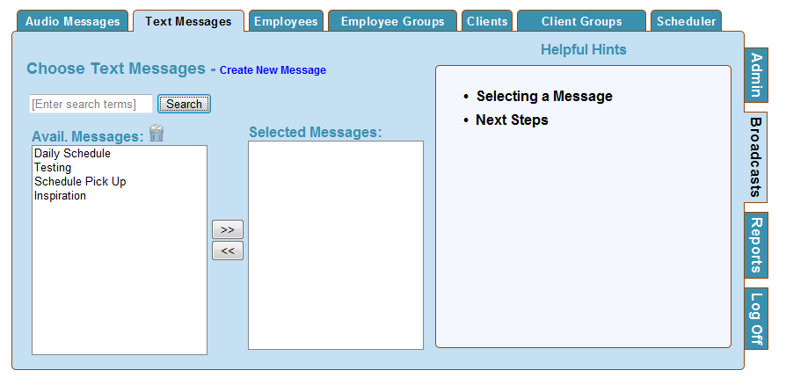

Creating a New Text Message
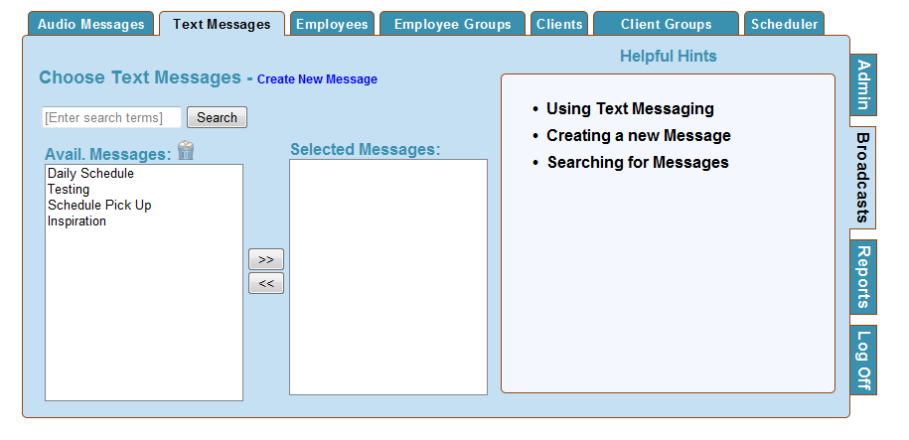
Click Create New Message to view message creation form.

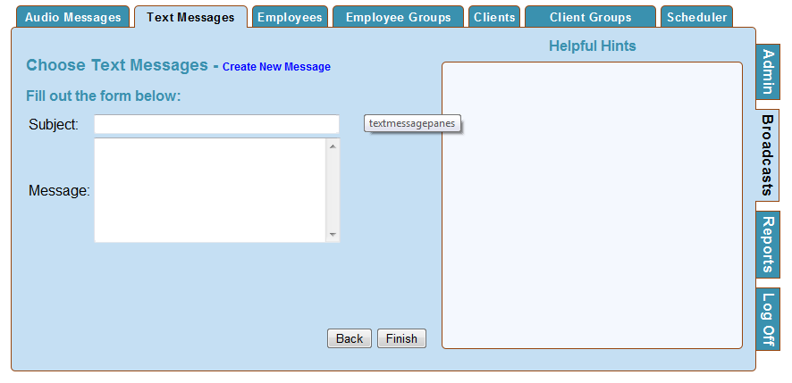
  - Name the message using the Subject box
  - Type the body of your message
  - Click the "Finish" button to save your text message

- Search for your desired message by leaving the search term box empty and clicking the Search button to view all messages or enter a search term to view specific matches.
- Click on the message and then click the arrow button pointing to the right or double click the message to add it to the Selected Messages box
- To Delete a message click on the message and then click the trash can icon.

Selecting an Existing Text Message
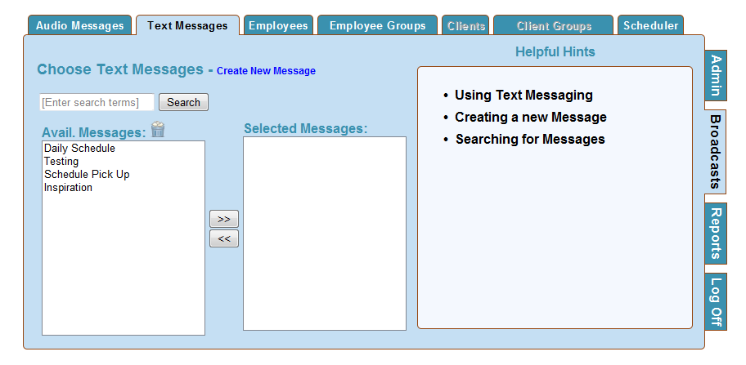

Employees
Once you have selected theText message that you would like to send out, you must pick the employee(s) or employee group(s) that you would like to send the text messasge to.
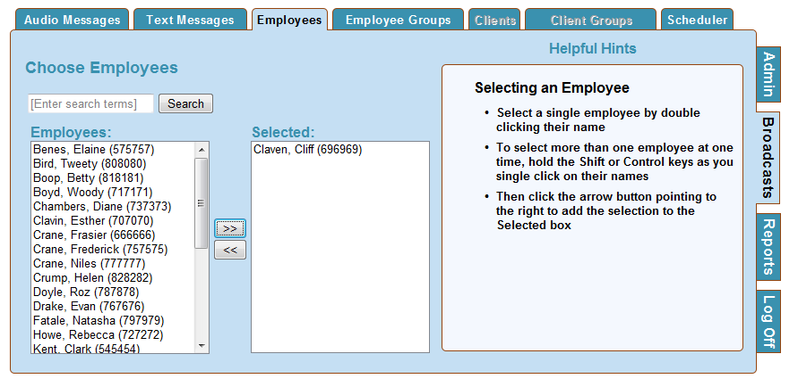
Search for Employees
- Enter in a search term in the Search box and click search to view specific employees
- Leave the Search field empty and click the Search button to view a list of all employees

Assign Employees
- Use the Employees Tab to select an employee(s) to assign Text messages to be sent according to the specified schedule
- Click on the name of the employee(s) that you would like to receive the text message and then click the arrow button that points to the right, or double click on the name. The employee will appear in the Selected box.
- To select multiple employees at the same time use the shift or control keys.

Employee Groups
Use the Employee Groups Tab to select an employee group(s) to assign the Text messages to be sent according to the specified schedule.
Selecting group(s) is an optional step in assigning a message to be heard or sent.

Where do Groups Come From?
Groups are created in your billing, payroll and scheduling software and are then transferred to Dial-N-Document. To learn more about creating and managing groups contact your billing/payroll company or look in the materials they have provided.
Search for Employee Groups
- Enter in a search term in the Search box and click search to view specific employee groups
- Leave the Search field empty and click the Search button to view a list of all employee groups
- Click the Auto Load Box and then the Group Name to view the Group members.
Selecting an Employee Group
- Click on the Group(s) in the Current Groups box
- Click the arrow pointing down to select the group(s)

Scheduling a Message
Go to the Scheduler Tab and click the Finish Tab button to send the text message.

Once you have clicked the Finish button a box will appear that will allow you to enter a text reply phone number. You must enter the phone number and the carrier address information. Example:
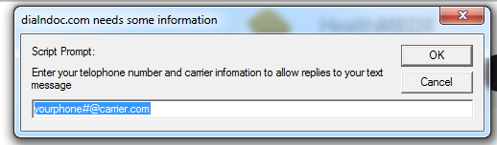

You will get the following message if the selected employee(s) does not have a cell phone number and carrier connected to their information.
