Validator ™
The Validator™ device was developed to provide true time and attendance verification where a location does not have a phone for use by the field staff. The Validator ™ device provides a secure and reliable method for identifying a location and the date and time that location was visited.
The Validator ™ device must be secured at the location using the security screw or serial numbered bands as provided by Dial-N-Document®. The Validator ™ device needs to be secured in such a manner so as to prevent field staff from being able to remove it from the location.
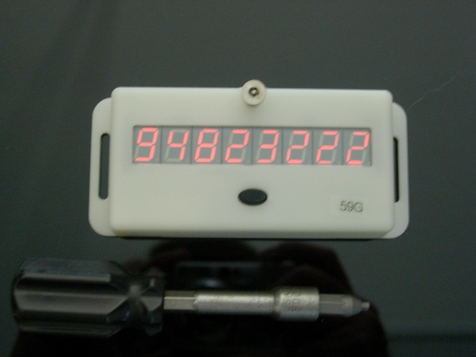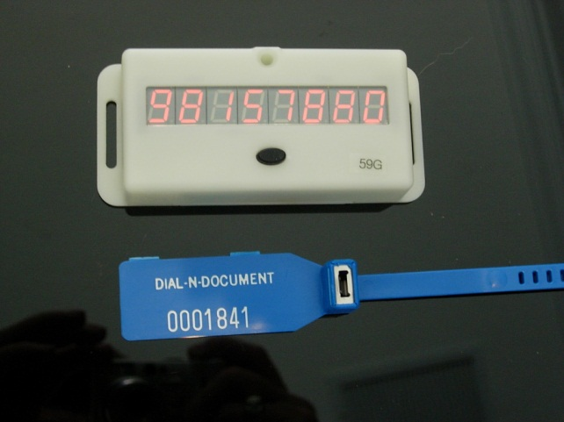

A properly installed Validator ™ should be inspected at irregular intervals to ensure it has not been removed or otherwise tampered with to guarantee its’ proper use.

Documentation of Time and Attendance utilizing the Validator ™
- Employee presses the button on the Validator ™ and writes the 8-digit number down on a piece of paper.
- Employee then calls the toll-free number and connects to Dial-N-Document’s® VoIP Documentation Service from an unrecognized phone number.
- After employee authentication has succeeded, the employee will be prompted to enter the 8-digit number from the Validator ™ device.
- Upon verification of the number entered by the employee, the documentation process will proceed as normal.

Assigning a Validator ™
The Validator ™ must be assigned to one of more clients. To assign a Validator ™ to a client click on the Assign a Validator ™to a Client button and then click the Next button at the bottom of the screen.
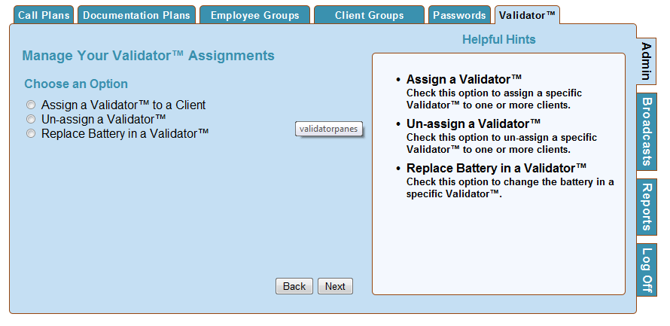

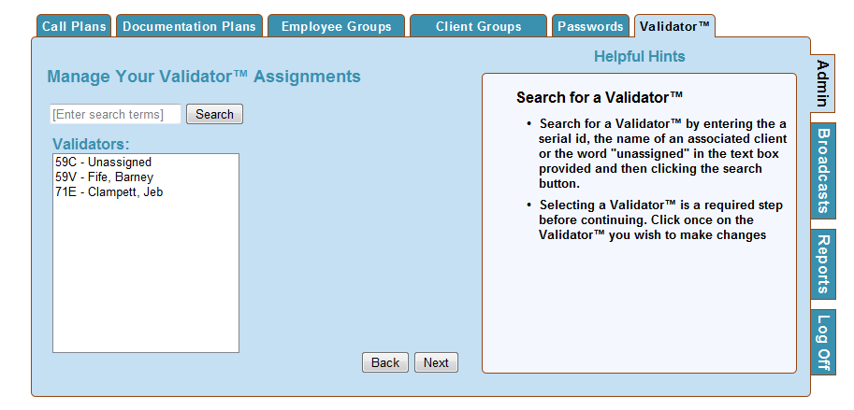
Search for a Validator™
  - Search for a Validator™ by entering the a serial id, the name of an associated client the word "unassigned" in the text box provided, or simply click the Search button to bring up all of the Validators™ and then clicking the search button.
  - Selecting a Validator™ is a required step before continuing. Click once on the Validator™ you wish to make changes and then click the Next button at the bottom of the screen.
Selecting a Client
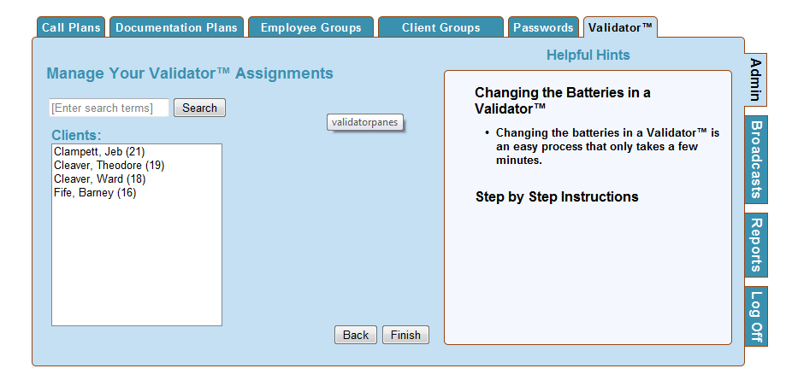
Search for a Client
  - Search for a Client by entering the serial id, the name of the employee , or simply click the Search button to bring up all of the Validators™ and then clicking the search button.
  - Selecting a Client to remove from the Validator™ is a required step before continuing. Click once on the patient you wish to un-assign and then click the Finish button at the bottom of the screen.

Un-assign a Validator™
Un-assigning a Validator™ is done when a Validator™ is removed from a home or patient location and will not be immediately re-assigned to another location. Once unassigned, the Validator™ will show on the list as un-assigned.
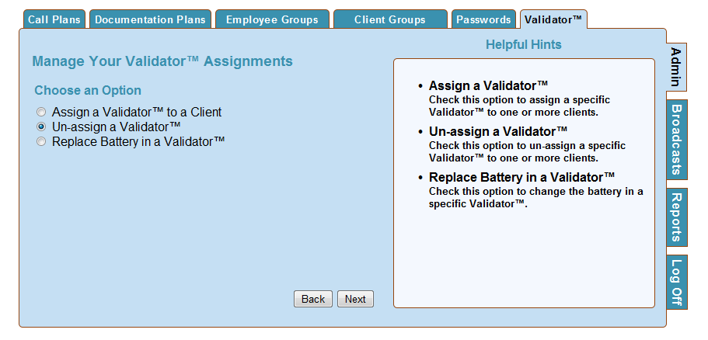
To Un-assign a Validator ™ to a client click on the Un-assign a Validator ™ button and then click the Next button at the bottom of the screen.
Search for a Validator™
  - Search for a Validator™ by entering the serial id, the name of an associated client the word "unassigned" in the text box provided, or simply click the Search button to bring up all of the Validators™ and then clicking the search button.
  - Selecting a Validator™ is a required step before continuing. Click once on the Validator™ you wish to make changes and then click the Next button at the bottom of the screen.
Selecting a Client
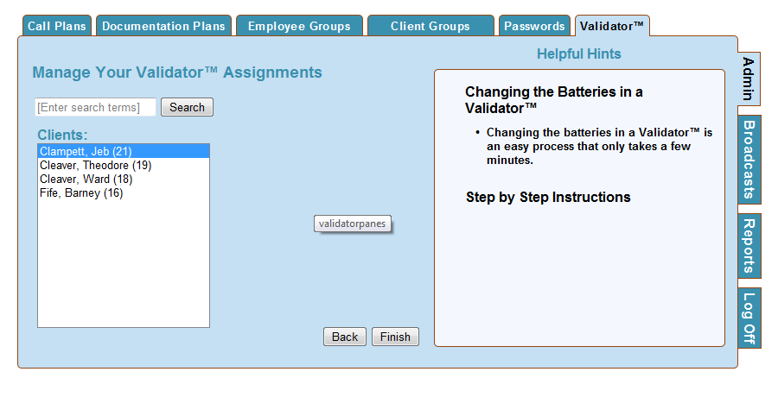
Search for a Client
  - Search for a Client by entering the serial id, the name of the employee , or simply click the Search button to bring up all of the Validators™ and then clicking the search button.
  - Selecting a Client to remove from the Validator™ is a required step before continuing. Click once on the patient you wish to un-assign and then click the Finish button at the bottom of the screen.

Replace the Battery in the Validator™
Changing the batteries in a Validator™ is an easy process that only takes a few minutes. Click on the Replace Battery in a Validator™ button and then click the Next button.

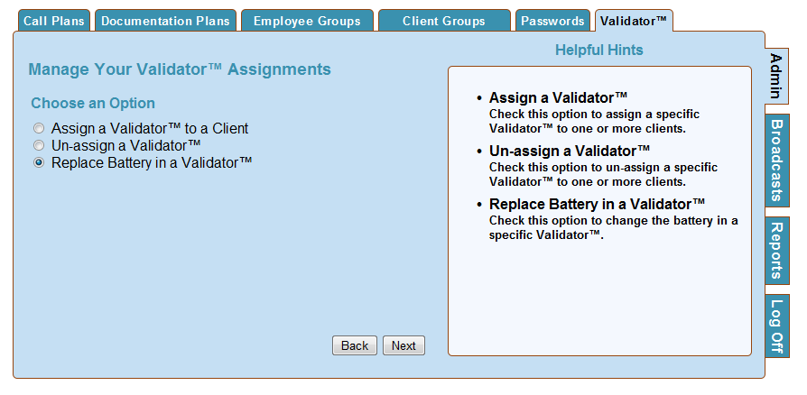
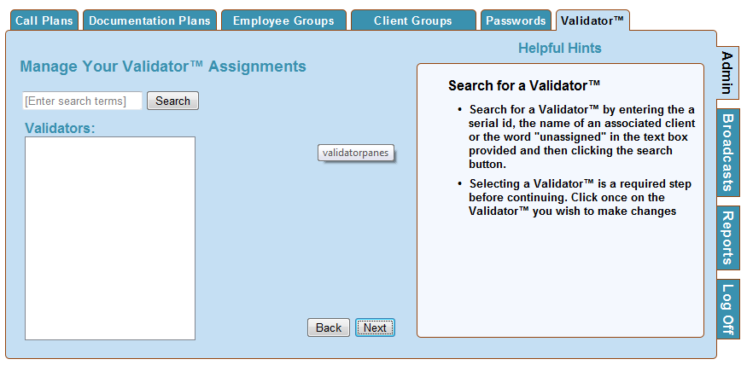
Search for a Validator™
  - Search for a Validator™ by entering the serial id, the name of an associated client the word "unassigned" in the text box provided, or simply click the Search button to bring up all of the Validators™ and then clicking the search button.
  - Selecting a Validator™ is a required step before continuing. Click once on the Validator™ you wish to make changes and then click the Next button at the bottom of the screen.

Search for a Client
  - Search for a Client by entering the serial id, the name of the client , or simply click the Search button to bring up all of the clients and then clicking the search button.
  - Selecting a Client to remove from the Validator™ is a required step before continuing. Click once on the patient you wish to un-assign and then click the Next button at the bottom of the screen.
Step by Step Instructions
1. Remove the battery lid
2. Remove the old batteries
3. Insert the new batteries and replace the lid
4. Push the button on the front
5. After the number appears press the button again and the number will disappear
6. Wait a few minutes and press the button again
7. On the web page enter the Validators™ serial number and Validator™ 8 digit number that appears into the box provided and press the "Finish" button. A success alert should pop up.
